Name: _____________________ Instructor: Peter Sallay Math 1332 Exam IV

For full credit; Set up the problem ***and*** write the final answer. Use extra scratch paper if needed.

1. Explain whether this statement describes a linear or exponential relationship.

*The price of a certain product is increasing at a rate of $2.30 per year. __________________________________*

*The value of farm land in a certain state is increasing at a rate of 4% per year. ________________________________*

1. The Board of Directors of a neighborhood Home Owner’s Association has decided they need to raise dues by 10% each and every year to help pay for pool improvements. If dues are $60 per month this year, how much will they be in 6 years?
2. Enrollment at a certain institution has been increasing by about 150 students each year. If the enrollment this year is 4800 students, how many students are expected to be enrolled 8 years from now?
3. Suppose a chess board has one grain of wheat on the First Square, two grains on the second square, four grains on the third square, eight grains on the fourth square, and so on, up to and including the 18th square. Find the total number of grains on the board.
4. Suppose that a population has a doubling time of 18 years. By what factor will it grow in 72 years?
5. If the doubling time of a state’s population is 38 years, how long does it take for the population to increase by a factor of 8?
6. The price of a certain commodity rises by 4% every year. What is the approximate doubling time for the price of the commodity?
7. Suppose that the consumer price index of a country is decreasing at the rate of 4.3% per year. Use the approximate half-life formula to estimate the half-life.
8. Suppose that a quantity is halved every 20 years. Use the approximate half-life formula to estimate its decay rate.
9. If the half-life of a drug in the bloodstream is 15 hours, how much drug is left in the bloodstream 36 hours after a 400 milligram dose?
10. In a function involving the altitude, over time, of a ball thrown into the air, identify the variables. Describe which variables are independent and dependent.

|  |  |
| --- | --- |
| Independent |  |
| Dependent |  |

Depth under water in meters is related to the water pressure at that depth in atmospheres. The following data points represent this relationship. (#12-#13)

|  |  |  |  |  |  |  |  |
| --- | --- | --- | --- | --- | --- | --- | --- |
| Depth | 0 | 1 | 3 | 4 | 10 | 30 | 91 |
| Pressure | 1 | 1.1 | 1.2 | 1.4 | 2 | 4 | 10 |

1. What is the depth when a diver is experiencing 2 atmospheres of pressure?
2. When a diver is at a depth of 4 meters, how many atmospheres of pressure is he experiencing?

Refer to this graph for #14 and #15.

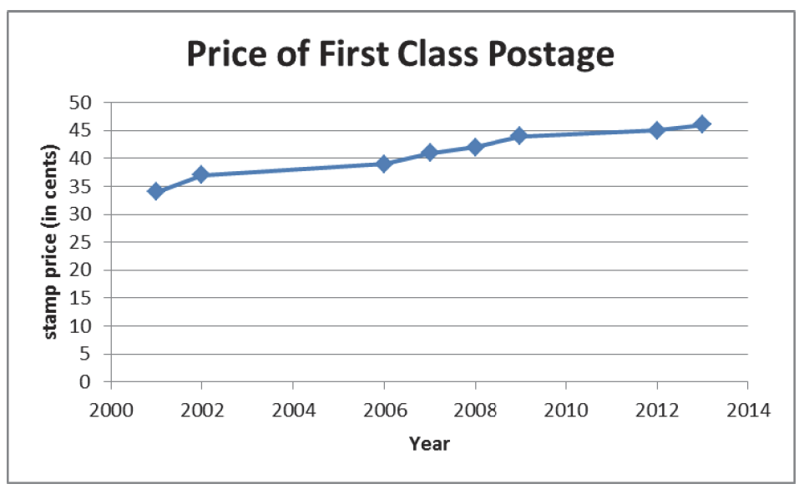

1. Use the notation (independent variable, dependent variable) to characterize the function in the graph.
2. Describe the domain and the range of the function.

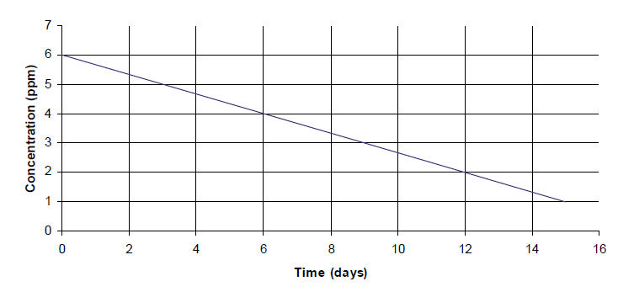Refer to this graph for #16-#20

1. Estimate the concentration on day 9?____________
2. What is the rate of change in terms of concentration per day?_________________
3. Find the initial value of the concentration.____________________
4. Write an equation representing concentration, *c*, as a function of time, *t*.____________________
5. Use the equation to predict the concentration on day 15._________________________
6. The population of a certain city has been growing at a rate of 3% per year. If the population was 75,000 in 2000, and this rate of growth continues, what might the population of this city be in 2030?
7. Linda placed $1000 in a brokerage account that has been increasing its value by 11% per year. At the same time, John began placing $1000 under a mattress at the beginning of each year. Who had more money after 20 years, and by how much?
8. The average price of a home in a certain town was $86,000 in 2007, but home prices have been *falling* by 4% per year. Create an exponential function of the form *Q*  *Q*0 1 *r* *t* to model this situation. Be sure to clearly identify each of the variables in your function.
9. Suppose that poaching reduces the population of an endangered animal by 12% per year. Further, suppose that when the population of this animal falls below 45, its extinction is inevitable (owing to the lack of reproductive options without severe in-breeding). If the current population of this animal is 1400, in how many years will it face extinction?
10. A toxic radioactive substance in the amount of 5 milligrams per square centimeter is detected in the ventilating ducts of an old nuclear processing building. If the half-life of the substance is 11 years, what was the amount of the substance when it was deposited 38 years ago?
11. A fossilized bone contains about 62% of its original carbon-14. How old is the bone? (The half-life of carbon-14 is about 5700 years.)

Exam IV Formula Chart

|  |  |
| --- | --- |
| Exponential Growth Model |  |
| Exponential Decay Model |  |
| Rule of 70 | P represents the growth or decay rate in percent form  t represents the time it takes to double or half |
| Rate of change or slope |  |
| Equation of a linear function |  |
| Equation of an exponential function |  |